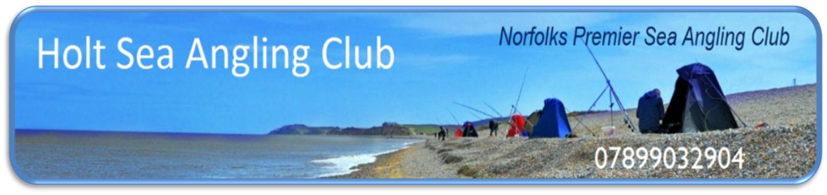

To: All Holt SAC Members,

Re. 2016 AGM & Presentation Dinner

Please be informed that the Holt Sea Angling Club Annual General Meeting and Presentation Dinner will take place on Saturday 19th March at the Kelling Heath Holiday Park, Weybourne, Holt, Norfolk, NR25 7HW. Website for this location is http://www.kellingheath.co.uk/ .
The AGM will be held in the Forge bar of this complex commencing at 2:30 p.m. and should last about 2½ hours depending on the debates. The Presentation Dinner will be held in the Forge restaurant commencing from 7:00 p.m. for a 7:30 p.m. start.
The following information is enclosed …
- Provisional AGM Agenda.
- Presentation Dinner Menu.
- Survey for above and next year.
The Survey is required to establish numbers at the AGM, Dinner numbers and Menu requirements for the dinner along with who will be joining Holt SAC for the coming season.
The Survey is generally self-explanatory where for the meal menu options I need to know how many in your party require each option (i.e. if 4 want soup enter 4 in box (a), 2 want the roast enter 2 in box (g) and so on). Monies for the meal will be collected on the night and please note that each menu option is costed separately this year. Please note that if you register for the meal and do not turn up without warning then you could be liable to pay the meal charge. Please also detail any topics you wish to have included in “Any Other Business” at the AGM.
Please return the survey in the enclosed addressed envelope by Friday 4th March 2016 at the latest. Non receipt of the document will indicate that you will not be participating in either of the above two events nor joining Holt SAC for the 2016-2017 season.
I look forward to your reply.

Regards,
Tony Thomas
Holt SAC Chairman

